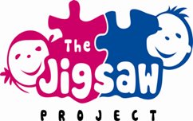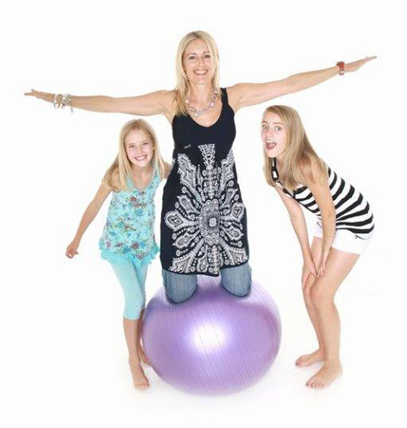New class starting on 22nd February!  Parent & child Pilates!  These classes are a great way for you and your child to do something healthy and enjoyable together.  If you are interested or would like more information, please text me on 07935518393. Spaces are limited so sign up as soon as possible!  Janice (Jigsaw Worker)  ** Open to children in P6 and P7 and their parents/carers. | You’re invited along to our Pilates classes aimed at parents/carers and their children!  ────  Dates are:  22nd February  1st March  15th March  22nd March  ────  These free classes run from 3-4pm in Camphill’s main hall  ────  This is an activity which will help kids improve motor skills, balance, co-ordination, strength and concentration. And there are great health benefits for you too!  ────  First come first served!
Parent & Child Pilates Reply Form  If you are interested in the Parent/Carer & Child Pilates class starting at Camphill Primary School for four weeks only on 22nd February (other dates are: 1st March, 15th March & 22nd March) from 3-4pm, then please write your name and number below and bring this back to school! Please check the website for the full information.  Thanks Janice (Jigsaw Worker)  Name: __________________________  Number: ________________________ | 