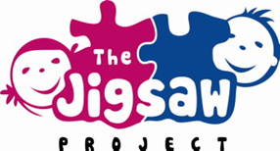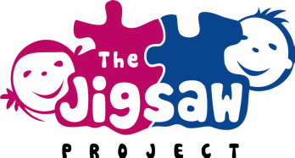**What’s On!**

**Take a look at what we have coming up in the next couple of months!**

***Camphill Coffee & Chat 2pm 6th February***



***Jigsaw will be hosting a Coffee & Chat on Safer Internet Day on 6th February between 2 – 3pm. Come along and have an informal chat about engaging with your children and their digital lives! Also, Joanne Campbell from the PSNI will be joining us for a talk on keeping safe online called “Behind the Screen”, date to be confirmed so keep an eye out for that!***





***New class starting on 22nd February!***

***Parent & child Pilates! Open to children in P6 & P7 and their parents/carers.***

***These classes are a great way for you and your child to do something healthy and enjoyable together. See the school website for further details.***

***If you are interested or would like more information, please text Janice on 07935518393. Spaces are limited so sign up as soon as possible!***

**Festival of Learning**

**Get active!!**

**Fun activities with your child**



**Health and wellbeing Information**

**DIARY DATE:** Tuesday 13th MARCH 2PM to 4pm in Camphill’s main hall