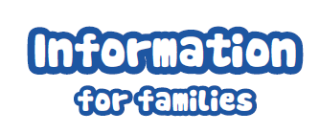


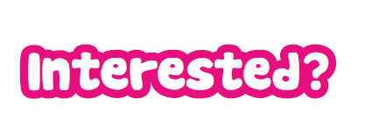


Hi, my name is Janice McCay and I am the new Jigsaw Family Worker for Camphill Primary School. There are many aspects to my role but my most important responsibility is to ensure that you and your child are supported throughout your child’s time in school.

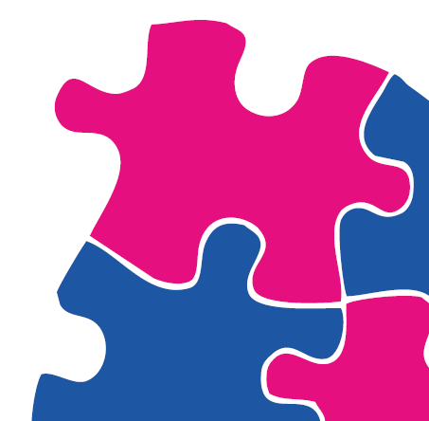
What can we offer?
We would like to support you anyway we can by:

- Ring or text me directly on 07935518393
- Leave a message at the office or with your child’s teacher
- We can arrange to meet in school, at home or wherever you feel comfortable

- Being the link between home and school
- Personal, social and emotional support for you and your child
- Information/support groups for parents in a range of topics relevant to the needs of children/families
- Running and providing support programmes all year: parenting programmes, coffee mornings, workshops, transition and body image
- Signposting to other agencies who can best support your needs
- Fun events for families including community and health initiatives

